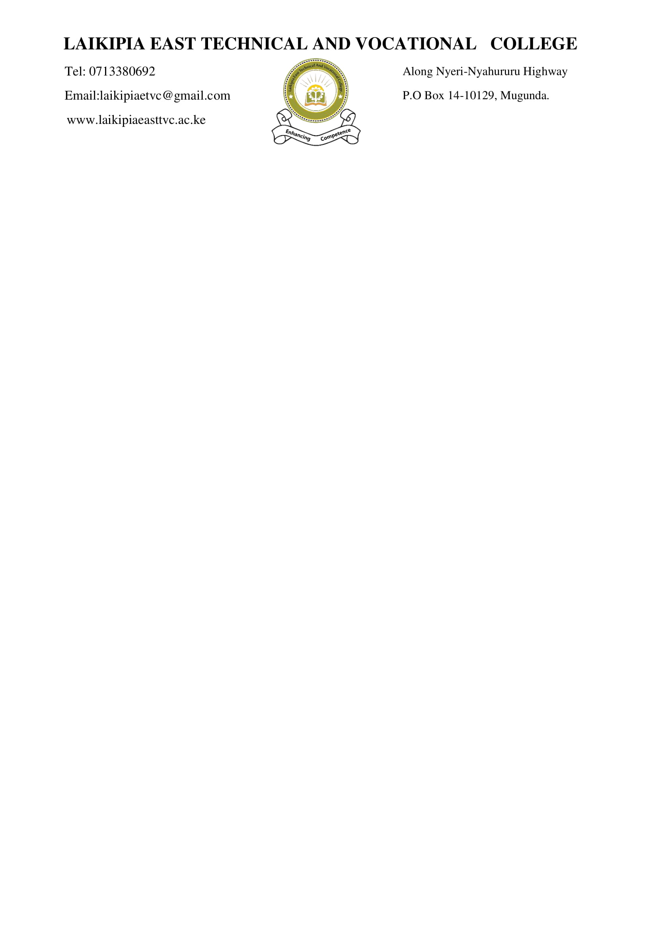

|  |  |  |  |
| --- | --- | --- | --- |
| **FORMATIVE ASSESSMENT TOOL** | | | |
| **UNIT OF COMPETENCY** | **DEVELOP COMPUTER PROGRAM** | **UNIT CODE** | **IT/OS/ICT/CR/10/6** |
| **QUALIFICATIONS: ICT TECHNICIAN**  **LEVEL 6** | |  |  |
| QUALIFICATION CODE: 061006T4ICT | | | |

**ASSESSORS INSTRUCTIONS**

This assessment requires the candidates to demonstrate competence against unit of competency; develop computer program

In this assessment, the candidate will be required to respond to written questions

1. Allocate **2 minutes** to each candidate to prepare for the assessment
2. Guide each candidate to fill the assessment tool with personal information, including the venue, Date and signature
3. Allocate **3 HOURS** for each candidate to respond to all written questions for every assessable Element
4. (**Section A: 40 marks Short-answer questions, Section B: 60 marks Extended answer questions**)

***NB/* A candidate should choose 3 questions from section B**

|  |  |
| --- | --- |
| Candidate’s name &Registration No. |  |
| Assessor’s name & Reg. code |  |
| Unit (s) of competency | DEVELOP COMPUTER PROGRAM |
| Venue of assessment |  |
| Date of assessment |  |

**SECTION A (40 MARKS)**

**Answer all questions in this section**

1. Differentiate between black box and white box testing. (4 Marks)
2. Write a C program that uses a loop to generate and display numbers 0 to 9 (4 marks)
3. Develop a pseudo code and a flowchart to print the largest number among two numbers entered by the user (6 marks)
4. Write a C program for the above question (4 marks)
5. List two relational operators and two logical operators used in C programming (4 Marks)
6. Using appropriate examples explain two types of programming errors [4 Marks]
7. Spiral approach of program development is essential in computer programming. State FOUR characteristics of spiral. (5 Marks)
8. Differentiate the following as used in programming
9. Global variable and a local variable (2 marks)
10. While loop and Do… while loop (2 marks)
11. Compiler and Interpreter (2 marks)
12. Assembly and Machine Language (2 marks)
13. Variables and constants (2 marks)

**SECTION B: (60 MARKS)**

**Attempt any THREE (3) questions in this section**

**QUESTION ONE**

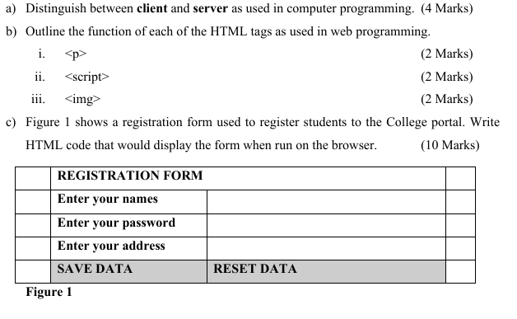

**QUESTION TWO**

1. Explain 4 categories of High-Level Languages (4 marks).
2. List and explain any 3 attributes of a good algorithm. (6 Marks)
3. Differentiate between a flowchart and pseudocode (5 Marks)
4. Give two advantages & three disadvantages of Machine language programming. (5 Marks)

**QUESTION THREE**

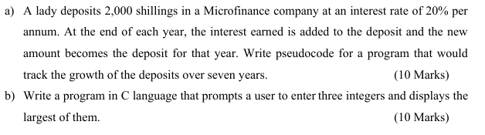**QUESTION FOUR**

1. Explain the process or stages of system development (15marks)
2. Explain what is meant by program portability? (5marks)